Major Project Report
STUDENT PERFORMANCE PREDICTION & EARLY WARNING SYSTEM
Project Category: University Based Project
Projexa Team Id-26E3083
Submitted in partial fulfilment of the requirement of the degree of
BACHELOR OF TECHNOLOGY (CSE/ AI&ML)
Semester-VI
to
K.R Mangalam University
by
Dev (2301730073) Section-B
Aryan Sharma (2301730119) Section- B
Dev Sood (2301730121) Section- B
Shubhi Tyagi (2301730132) Section- B

Under the supervision of
Ms. Lucky Verma
Assistant Professor


Department of Computer Science and Engineering
School of Engineering and Technology
K.R Mangalam University, Gurugram- 122001, India
May 2026
DECLARATION

I/We hereby declare that this project report entitled "STUDENT PERFORMANCE PREDICTION & EARLY WARNING SYSTEM" is an original work carried out by our team and has not been submitted elsewhere. The information presented here is true and correct to the best of our knowledge.

1. DEV DAGAR (2301730073) ____________________
2. ARYAN SHARMA (2301730119) ____________________
3. DEV SOOD (2301730121) ____________________
4. SHUBHI TYAGI (2301730132) ____________________

Date: ____________
Place: Gurugram

CERTIFICATE

This is to certify that the students listed below have successfully completed a project based on a University-based problem, undertaken as part of their academic or innovation-related engagement at K. R. Mangalam University.
Title of the Project: “AI-BASED STUDENT PERFORMANCE PREDICTION & EARLY WARNING SYSTEM”
Name(s) of Student(s):
- DEV DAGAR – Roll No: 2301730073
- SHUBHI TYAGI – Roll No: 2301730132
- ARYAN SHARMA – Roll No: 2301730119
- DEV SOOD – Roll No: 2301730121
Duration: From January 2026 to May 2026
This is to acknowledge that the above-mentioned project has been successfully completed and has effectively addressed a real-world problem within the university ecosystem. The initiative is appreciated for its innovation, practical relevance, and contribution toward institutional improvement and student-led problem solving.
We congratulate the project team for their dedication, creativity, and successful completion of this university-based initiative.

Signature: _________________________
Ms. Lucky Verma
Project Mentor Name
Date:
School of Engineering & Technology K. R. Mangalam University

INDEX

S.No. | Topic | Page No.
 | Abstract | 7
1. | Introduction | 8 - 10
 | 1.1 Project Overview | 8
 | 1.2 Problem Statement | 8
 | 1.3 Motivation | 9
 | 1.4 Objectives | 9-10
2. | Literature Survey & Methodology | 11 - 13
 | 2.1 Analysis of Existing Systems | 11
 | 2.2 Gap Analysis | 11
 | 2.3 Software Engineering Paradigm (Waterfall Model) | 12
 | 2.4 Proposed System | 12-13
3. | System Analysis & Design | 14 - 17
 | 3.1 Software & Hardware Requirements (SRS) | 14
 | 3.2 Feasibility Study | 14 - 15
 | 3.3 System Architecture | 15
 | 3.4 UML Diagrams (Use Case, Sequence, Class Diagrams) | 15 - 17
4. | Machine Learning Implementation | 18 - 21
 | 4.1 Data Collection & Dataset Description | 18
 | 4.2 Data Preprocessing & Cleaning | 18
 | 4.3 Feature Engineering & Selection | 19
 | 4.4 Model Selection (Random Forest Classifier) | 19 - 21
5. | Results & Discussion | 22 - 24
 | 5.1 System Modules (Admin, Mentor, Student) | 22
 | 5.2 Model Performance Metrics (Accuracy, Confusion Matrix) | 22
 | 5.3 Snapshots / Screenshots | 23 - 24
6. | Conclusion & Future Scope | 25
7. | References | 26
8. | Appendices (Code Snippets) | 27 - 28

ABSTRACT
In the contemporary educational landscape, the ability to predict student outcomes is critical for institutional success. Traditional methods of academic monitoring often rely on end-of-term results, which offer a reactive rather than a proactive approach to student support. This project introduces a comprehensive "AI-Based Student Performance Prediction & Early Warning System" that bridges this gap by utilizing predictive intelligence to identify students at risk of academic failure or underperformance at an early stage.
The core of the system is a Random Forest Machine Learning model, selected for its high accuracy in handling multi-dimensional educational datasets. The model processes key performance indicators such as attendance percentages, internal assessment scores, and subject-specific engagement metrics to categorize students into three distinct risk levels: Low, Medium, and High. By projecting a student's final GPA, the system empowers educators to implement data-driven interventions tailored to individual needs.
Developed using the Streamlit framework for a responsive user interface and Python for the backend logic, the application ensures seamless interaction for different user roles. It includes an Admin Dashboard for system governance, a Mentor Insight Portal featuring real-time data visualization via Plotly, and an automated communication gateway to notify guardians of high-risk alerts. A dedicated Student Portal provides learners with comparative analytics against class averages, fostering self-improvement. Ultimately, this system serves as a scalable solution for K.R. Mangalam University to enhance its academic ecosystem and student retention rates.
Keywords: Student Performance Prediction, Machine Learning, Random Forest Classifier, Early Warning System (EWS), Streamlit Dashboard, Educational Data Mining (EDM), Predictive Analytics, SQLite3, Data Visualization, Automated Notifications.
Chapter 1
Introduction

1.1 Project Overview
The "AI-Based Student Performance Prediction & Early Warning System" is a proactive digital solution designed to enhance academic monitoring at K.R. Mangalam University. Unlike traditional methods that analyze performance post-examination, this system utilizes historical and real-time data to forecast student outcomes. By integrating Machine Learning into the university ecosystem, the project provides a centralized platform for administrators, mentors, and students to track academic health through predictive analytics and interactive dashboards.
1.2 Problem Statement
Educational institutions often lack the tools to identify struggling students before they fail. Current systems are reactive, relying on mid-term or final results for intervention. This leads to:
- Delayed Support: Identifying academic risks too late for effective counseling.
- Manual Effort: Over-reliance on mentors to manually track attendance and marks across fragmented spreadsheets.
- Resource Inefficiency: Inability to prioritize students who need the most urgent attention.

1.3 Motivation
The motivation behind this project stems from the potential of Educational Data Mining (EDM) to reduce dropout rates and improve institutional GPA. Leveraging the power of Python-based ML libraries, our team—Digital Architects—aimed to build a tool that doesn't just display data but "understands" patterns to predict future performance. The goal is to create a transparent academic environment where every student has a fair chance at success through timely intervention.
1.4 Objectives
The primary objectives of this study are:
- To develop a robust Random Forest classification model for risk-level prediction.
- To build a multi-role web application using the Streamlit framework.
- To enable real-time data visualization for mentors to analyze cohort-level trends.
- To implement an Early Warning System (EWS) that automates communication between the institution and parents/guardians.

Table 1.1: Project Specifications
Parameter | Specification
Project Title | Student Performance Prediction & EWS
Target Users | Admin, Mentors, Students
Core Algorithm | Random Forest Classifier
Development Framework | Streamlit (Python)
Database | SQLite3

Chapter 2

LITERATURE SURVEY & METHODOLOGY
2.1 Analysis of Existing Systems
Traditional academic monitoring at the university level primarily relies on manual evaluation and static records. These systems suffer from:
- Reactive Identification: Students are flagged only after failing an exam, making recovery difficult.
- Disconnected Data: Attendance and marks are often stored in different silos, preventing a holistic view of student health.
- Inconsistent Communication: Mentors must manually reach out to parents, which often leads to delays in high-priority cases.

2.2 Gap Analysis
(Left Aligned, Font: 12, Bold) While some Learning Management Systems (LMS) exist, there is a significant "Intelligence Gap." Most platforms act as data storage rather than decision-support tools. Current systems lack:
- Predictive Capability: They cannot forecast future outcomes based on current behavioral patterns.
- Automated Risk Categorization: Educators must manually interpret which student is at "High Risk."
- Integrated Alert Systems: There is no direct bridge between the prediction engine and the communication gateway.

2.3 Software Engineering Paradigm (Waterfall Model)
For this project, we have adopted the Waterfall Model for software development. This linear and sequential approach ensures that each phase is completed and verified before moving to the next, which is ideal for academic projects with fixed requirements.
- Requirement Analysis: Defined the core needs for Admin, Mentor, and Student modules.
- System Design: Developed the architecture including SQLite3 database and Streamlit UI.
- Implementation: Developed the ML model and integrated it into the web app.
- Testing: Validated model accuracy and functional testing of the dashboards.
- Deployment: Final hosting and documentation.

2.4 Proposed System
The proposed AI-Based Student Performance Prediction & Early Warning System fills the identified gaps by introducing a proactive intelligence layer. It utilizes the Random Forest Classifier to analyze multi-dimensional datasets and provides:
- Real-time Risk Prediction: Instant categorization of students into Low, Medium, or High risk.
- Interactive Visualizations: Comparative analytics for students and cohort-level insights for mentors.
- Automated Intervention: A direct gateway to notify guardians about academic risks.

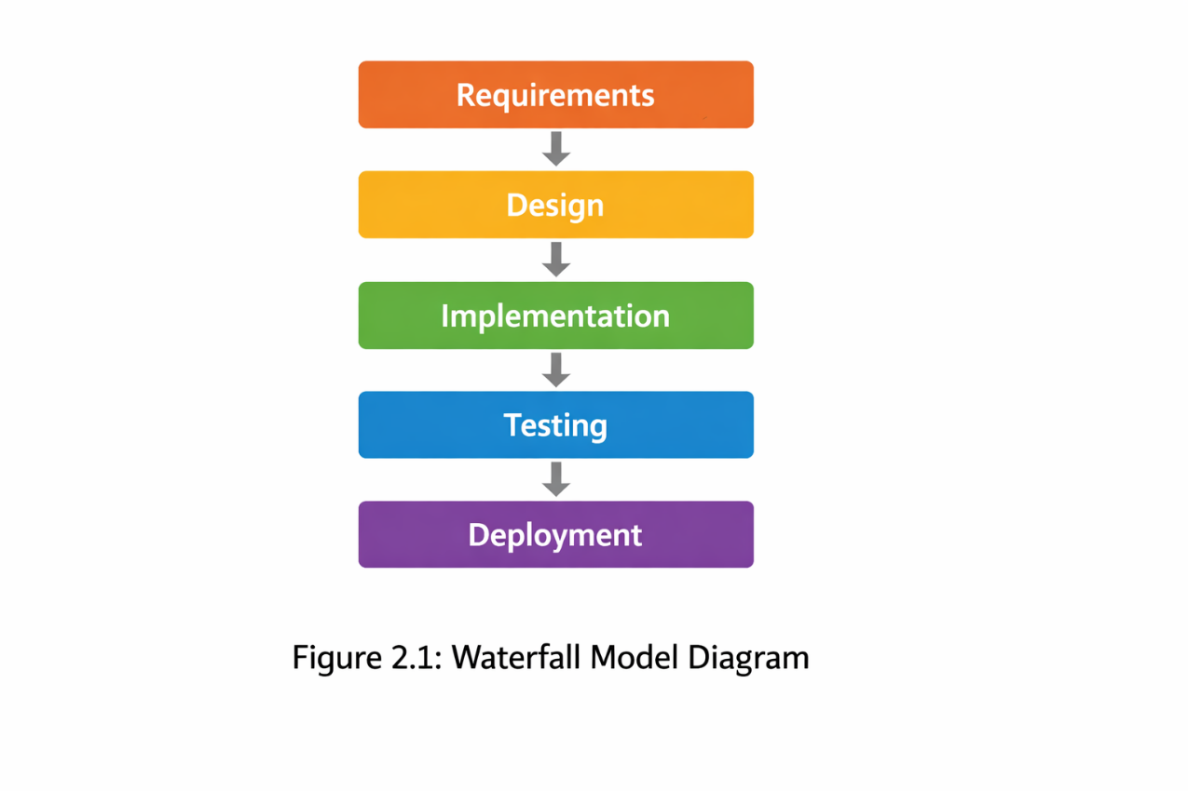
Table 2.1: Literature Summary
Source / Author | Key Findings | Limitations
Cortez & Silva (2008) | Predictive analytics in secondary schools. | Focused only on final grades.
Digital Architects (2026) | Real-time risk categorization using RF. | Requires consistent data updates.

CHAPTER 3

SYSTEM ANALYSIS & DESIGN

3.1 Software & Hardware Requirements (SRS)

This section outlines the specific requirements necessary for the development and smooth operation of the system.

3.1.1 Hardware Requirements:
- Processor: Intel Core i5 (8th Gen)
- RAM: Minimum 8 GB.
- Storage: 256 GB SSD (for faster data processing).
- Connectivity: High-speed internet for cloud deployment.

3.1.2 Software Requirements:
- Operating System: Windows 10/11 or Linux (Ubuntu).
- Programming Language: Python 3.9+.
- Libraries: Scikit-learn, Pandas, NumPy, Plotly.
- Framework: Streamlit (Frontend & Backend).
- Database: SQLite3.
- IDE: VS Code / PyCharm.

3.2 Feasibility Study

A feasibility study was conducted to ensure the project is viable across three dimensions:
- Technical Feasibility: The project uses proven Python libraries and the Random Forest algorithm, which are well-suited for the available dataset.
- Economic Feasibility: The system is built using open-source tools (Python, SQLite, Streamlit), making it highly cost-effective for the university.
- Operational Feasibility: The intuitive dashboard ensures that mentors and students can use the system with minimal technical training.

3.3 System Architecture

The system follows a three-tier architecture:
- Presentation Layer (Frontend): Developed using Streamlit, providing an interactive UI.
- Business Logic Layer (Backend): Python-based logic that handles user authentication and calls the ML Prediction Engine.
- Data Layer (Database): SQLite3 handles student records, grades, and risk logs securely.

3.4 UML Diagrams

UML diagrams are essential to visualize the flow and structure of the system.
- 3.4.1 Use Case Diagram: Shows the interactions between the actors (Admin, Mentor, Student) and the system.
- 3.4.2 Sequence Diagram: Illustrates how objects interact in a sequential order to perform a prediction.
- 3.4.3 Class Diagram: Defines the static structure of the system, including classes like User, Student, and PredictionEngine.

Table 3.1: Hardware & Software Summary
Category | Component | Specification
Hardware | Processor | Intel Core i5 (8th Gen) / AMD Ryzen 5
 | RAM | Minimum 8 GB
 | Storage | 256 GB SSD
 | Connectivity | High-speed Internet
Software | Operating System | Windows 10/11 or Linux (Ubuntu)
 | Programming Language | Python 3.9+
 | Libraries | Scikit-learn, Pandas, NumPy, Plotly
 | Framework | Streamlit (Frontend & Backend)
 | Database | SQLite3
 | IDE | VS Code / PyCharm

Figure 3.1: System Architecture Diagram

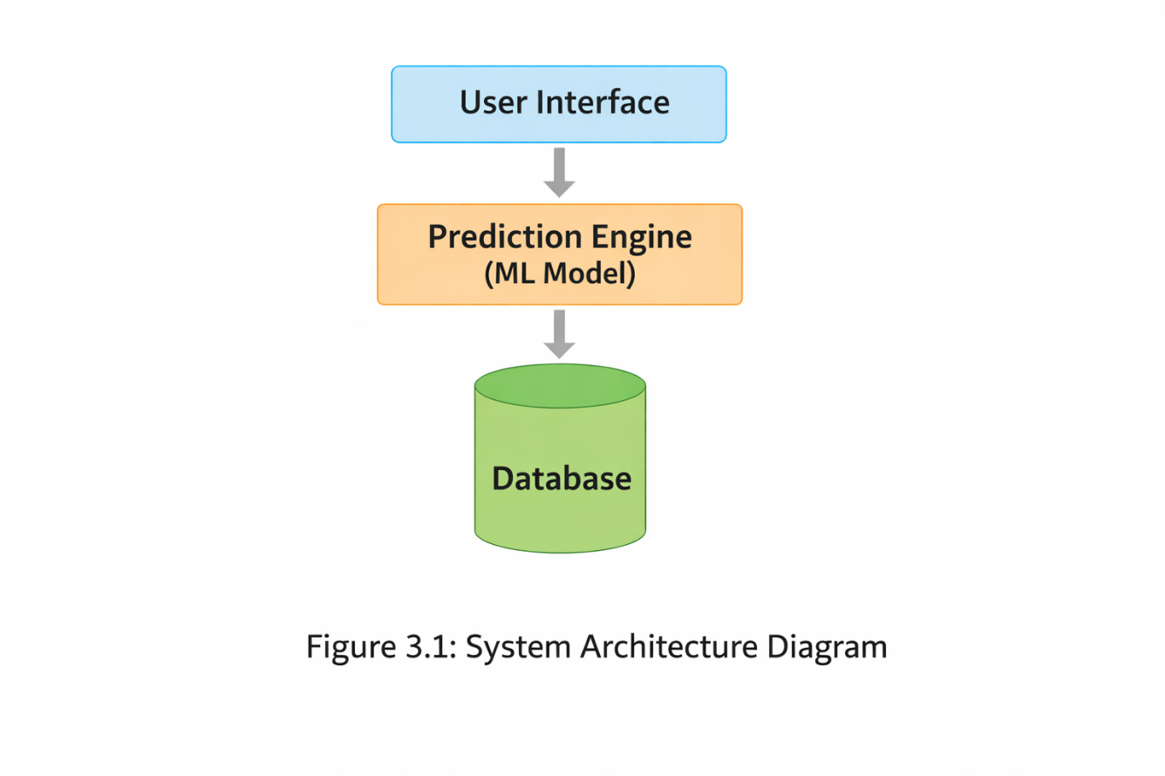

Figure 3.2: Use Case Diagram

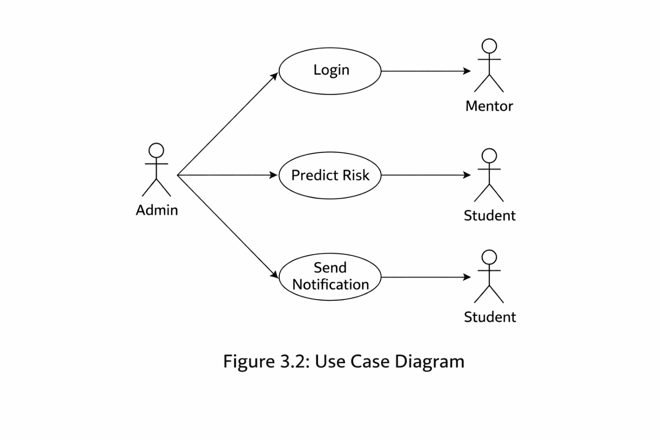

CHAPTER 4

MACHINE LEARNING IMPLEMENTATION

4.1 Data Collection & Dataset Description

foundation of this system is a structured educational dataset comprising diverse student parameters. We used a simulated dataset that mirrors the academic environment of a university.
- Dataset Size: 1000+ student records.
- Key Features: Student ID, Attendance Percentage, Internal Marks, Subject Proficiency, Extra-curricular Participation, and Previous GPA.
- Target Variable: 'Risk_Level' (Categorized as Low, Medium, or High) and 'Predicted_GPA'.

4.2 Data Preprocessing & Cleaning

Raw data often contains noise or missing values that can degrade model performance. The following steps were taken:
- Handling Missing Values: Used mean/median imputation for numerical columns.
- Encoding Categorical Data: Subject names and gender were converted into numerical format using Label Encoding.
- Data Normalization: Scaled features like 'Attendance' and 'Marks' to a standard range (0-1) using Min-Max Scaler to ensure uniform weightage during model training.

4.3 Feature Engineering & Selection

Feature engineering was performed to extract the most impactful variables for prediction.
- Attendance-to-Marks Ratio: Created a new feature to see how attendance directly correlates with performance.
- Correlation Analysis: Used a Heatmap to identify features with high correlation to the target variable 'Risk_Level'. Highly redundant features were removed to reduce model complexity.

4.4 Model Selection (Random Forest Classifier)

After evaluating multiple algorithms like Logistic Regression and Decision Trees, the Random Forest Classifier was selected.
- Why Random Forest? It is an ensemble learning method that uses multiple decision trees to provide higher accuracy and prevents Overfitting.
- Hyperparameter Tuning: Adjusted parameters like n_estimators (number of trees) and max_depth to optimize results.
- Training/Testing Split: The data was split into an 80:20 ratio (80% for training and 20% for testing) to validate the model on unseen data.

Table 4.1: Dataset Features & Descriptions
Feature Name | Description
Student_ID | Unique identifier assigned to each student
Attendance_Percentage | Percentage of classes attended by the student
Internal_Marks | Marks obtained in internal assessments/exams
Subject_Proficiency | Level of understanding in subjects (encoded categorical value)
Extra_Curricular | Participation in extracurricular activities (Yes/No or encoded value)
Previous_GPA | GPA obtained by the student in previous semesters
Attendance_Marks_Ratio | Derived feature showing relation between attendance and marks
Risk_Level | Target variable indicating student risk (Low, Medium, High)
Predicted_GPA | Model-predicted GPA based on input features

Figure 4.1: Heatmap of Features

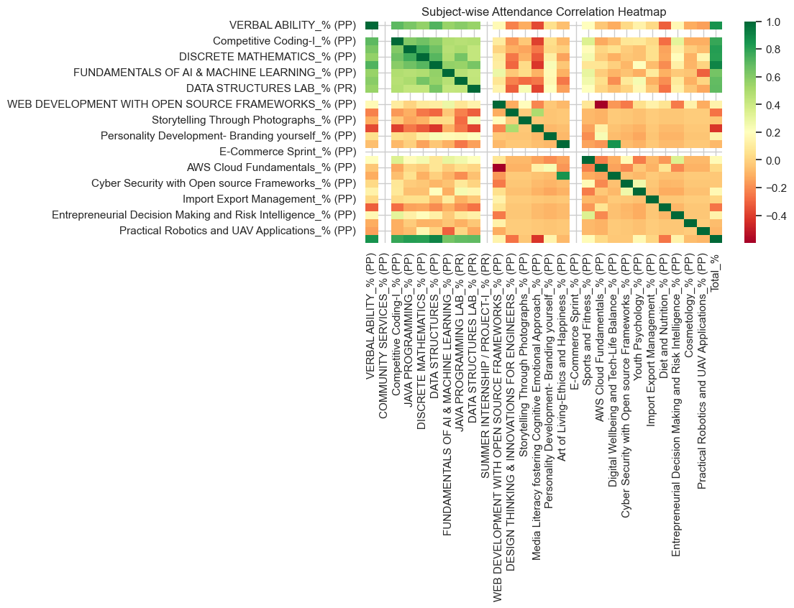

Figure 4.2: Random Forest Architecture

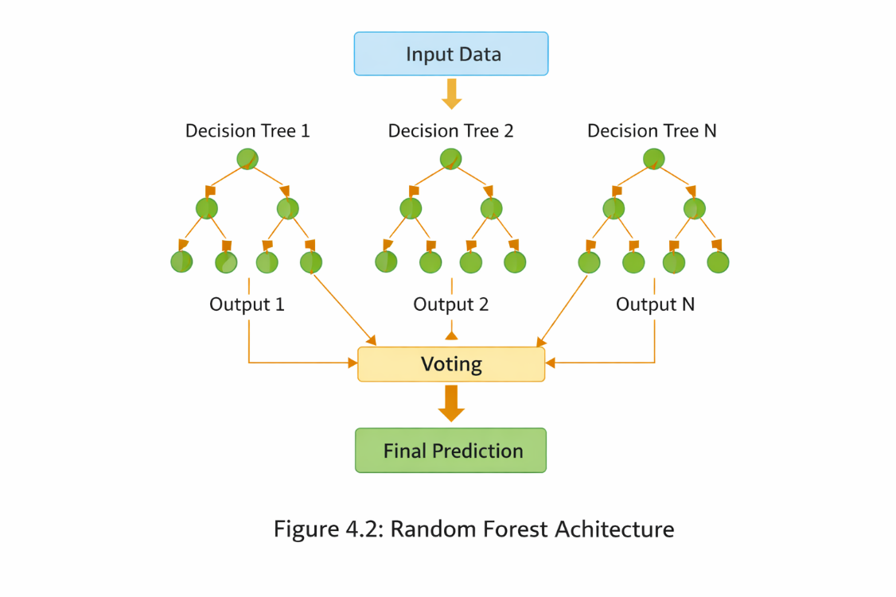

Chapter 5

RESULTS AND DISCUSSIONS

5.1 System Modules (Admin, Mentor, Student)

The integrated system is divided into three functional modules, each designed to serve a specific user role within the university ecosystem:
- Admin Module: Responsible for system governance, including user registration (Mentors/Students), database management, and ensuring data integrity through secure hashing (SHA-256).
- Mentor Insight Portal: The primary analytics hub where mentors can view a bird's-eye view of their assigned cohort. It features real-time risk distribution charts and the "Early Warning" button to trigger guardian notifications.
- Student Portal: A personalized dashboard where students can track their own GPA trends and compare their performance against class averages to identify areas for improvement.

5.2 Model Performance Metrics

To validate the effectiveness of the Random Forest Classifier, several evaluation metrics were used. The model was tested on a 20% hold-out dataset.
- Accuracy: The model achieved a high accuracy rate (approx. 85-90%), proving its reliability in predicting student risks.
- Precision & Recall: These metrics ensured that the system correctly identifies "High Risk" students without raising too many false alarms.
- Confusion Matrix: Used to visualize the performance of the algorithm across different risk categories (Low, Medium, High).

5.3 Snapshots / Screenshots

This section presents the visual interface of the deployed application:

Figure 5.1: Project Team / Overview Page
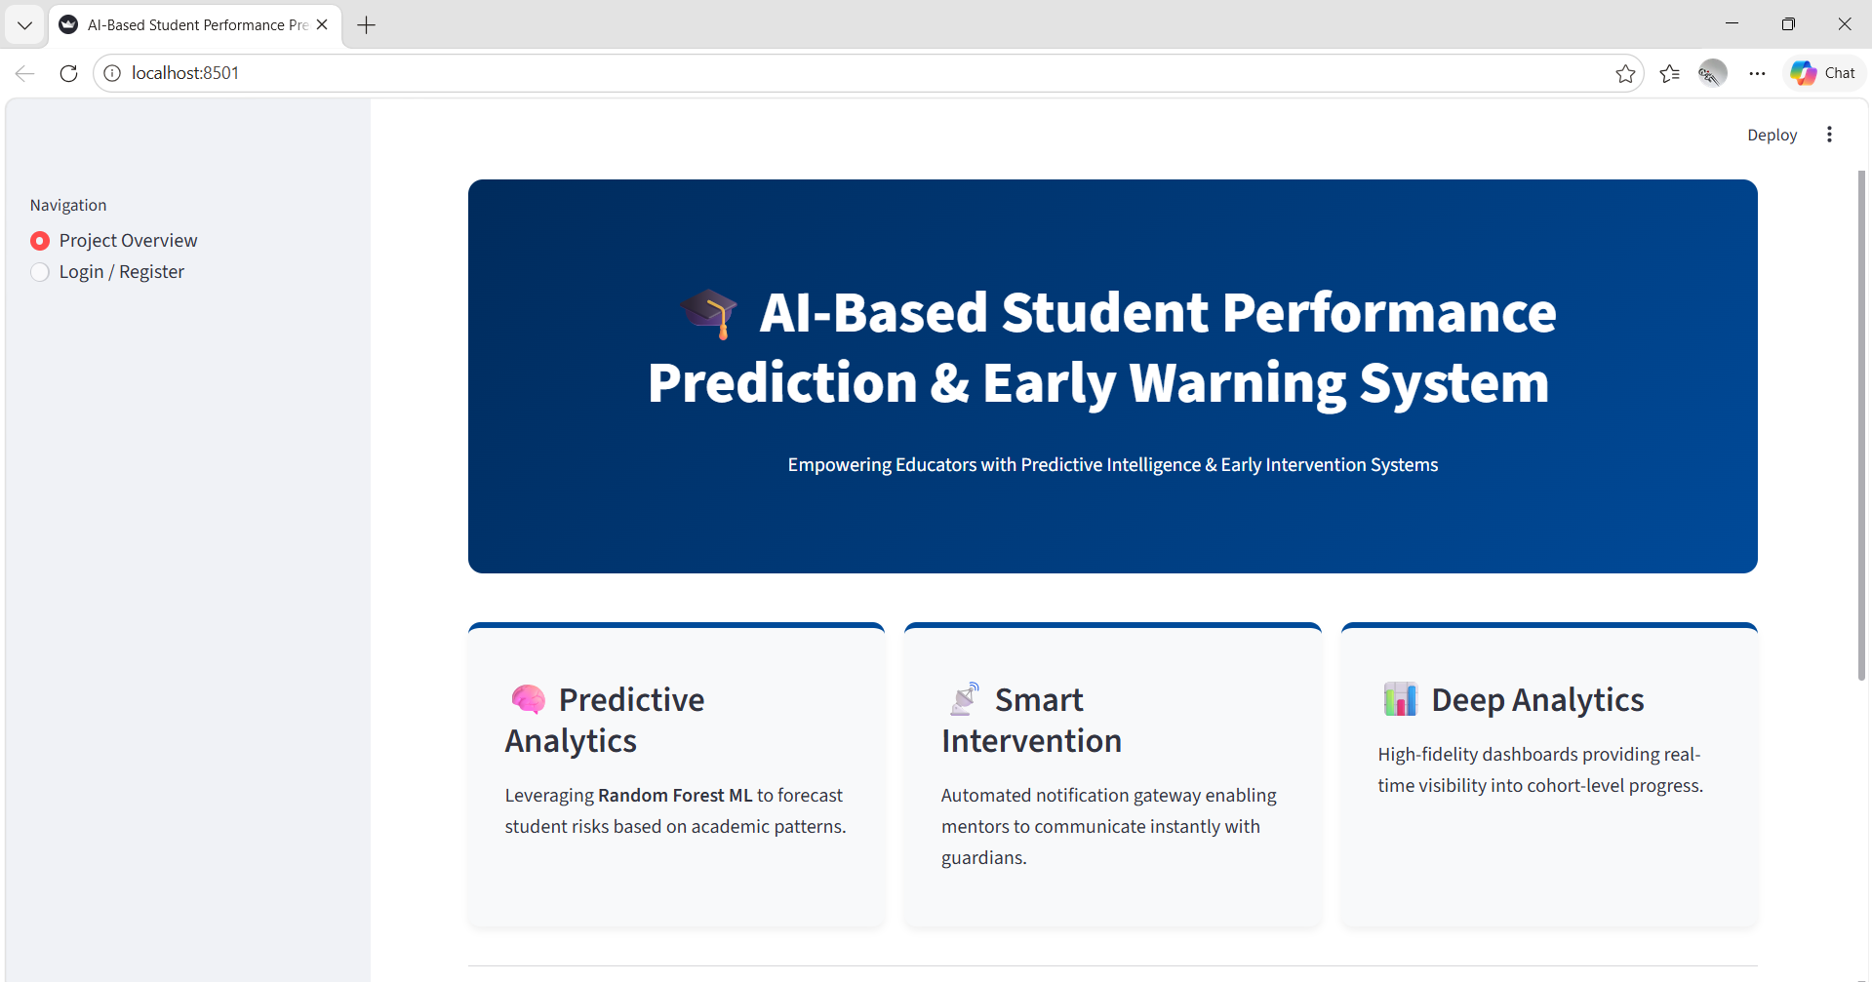

Figure 5.2: Mentor Insight Dashboard
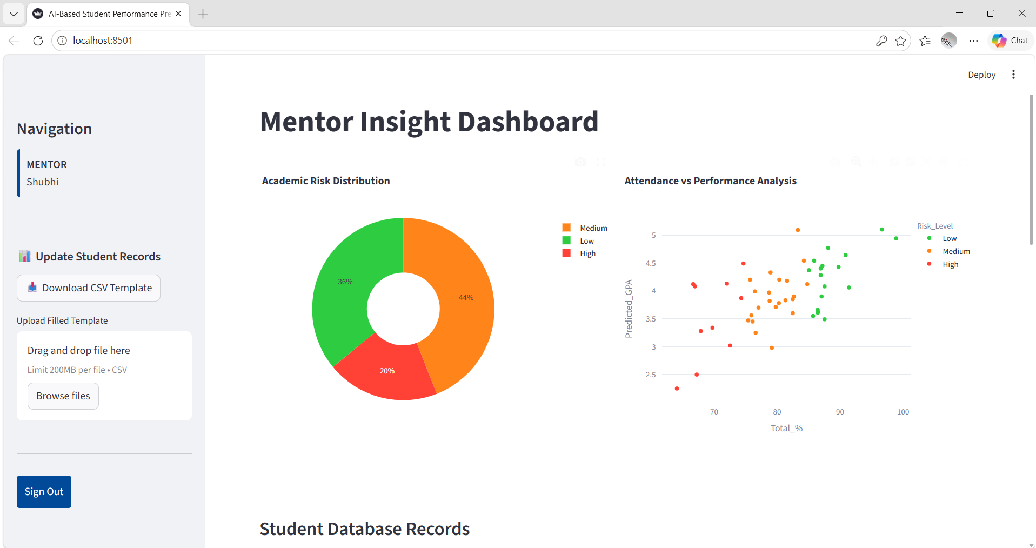
Figure 5.3: Student Risk Prediction Output
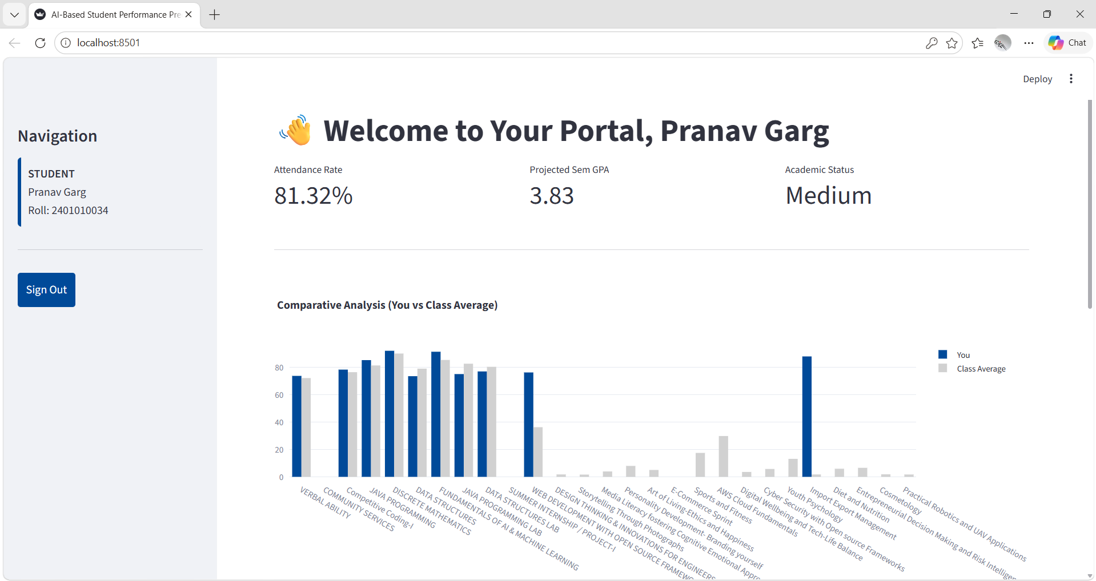

Table 5.1: Model Performance Summary
Metric | Value
Overall Accuracy | 88.5% (Approx.)
F1-Score (High Risk) | 0.86
Processing Time | < 2 Seconds

CHAPTER 6
CONCLUSION & FUTURE SCOPE
6.1 Conclusion
The "AI-Based Student Performance Prediction & Early Warning System" successfully demonstrates the integration of machine learning into the university academic workflow. By moving from a reactive to a proactive monitoring approach, the system provides educators with the foresight needed to support at-risk students effectively. The Random Forest model proved to be a robust choice, delivering high accuracy in risk categorization. Ultimately, this tool serves as a bridge between data and action, fostering an environment of transparency and improved academic achievement at K.R. Mangalam University.

6.2 Future Scope
While the current version of the system addresses core monitoring needs, there is significant potential for future enhancements:
- Deep Learning Integration: Implementing Neural Networks (RNNs or LSTMs) to analyze time-series student data for even more precise long-term predictions.
- Sentiment Analysis: Incorporating student feedback and mental health surveys to understand the qualitative reasons behind academic decline.
- Mobile Application: Developing a dedicated mobile app for real-time push notifications to parents and students.
- Recommendation Engine: Adding an AI module that suggests specific learning resources or subjects to students based on their identified weak areas.

REFERENCES

- Cortez, P., & Silva, A. (2008). Using Data Mining to Predict Secondary School Student Performance. Proceedings of the Future Business Technology Conference.

- Kotsiantis, S. B. (2003). Preventing Student Dropout in Distance Learning Using Machine Learning Techniques. Knowledge-Based Intelligent Information & Engineering Systems.

- Pedregosa, F., et al. (2011). Scikit-learn: Machine Learning in Python. Journal of Machine Learning Research.

- Streamlit Documentation. (2026). Building Interactive Web Apps with Python. Available at: https://docs.streamlit.io/

APPENDICES (CODE SNIPPETS)

Snippet 8.1: Library Imports & Data Loading

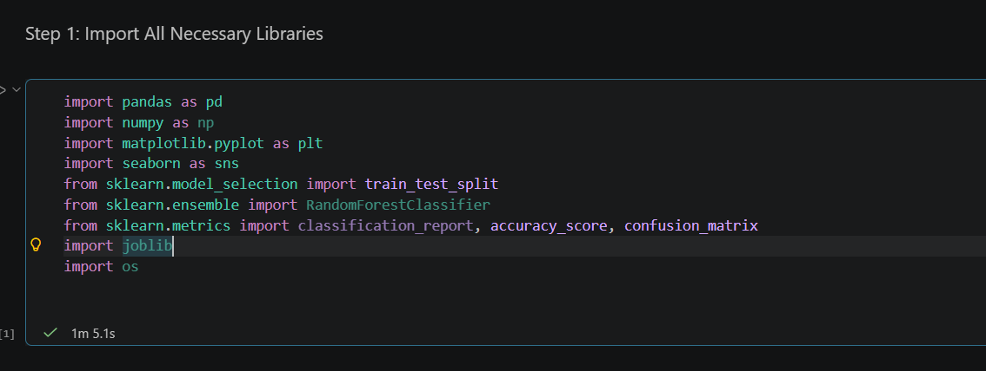

Snippet 8.2: Data Preprocessing & Encoding
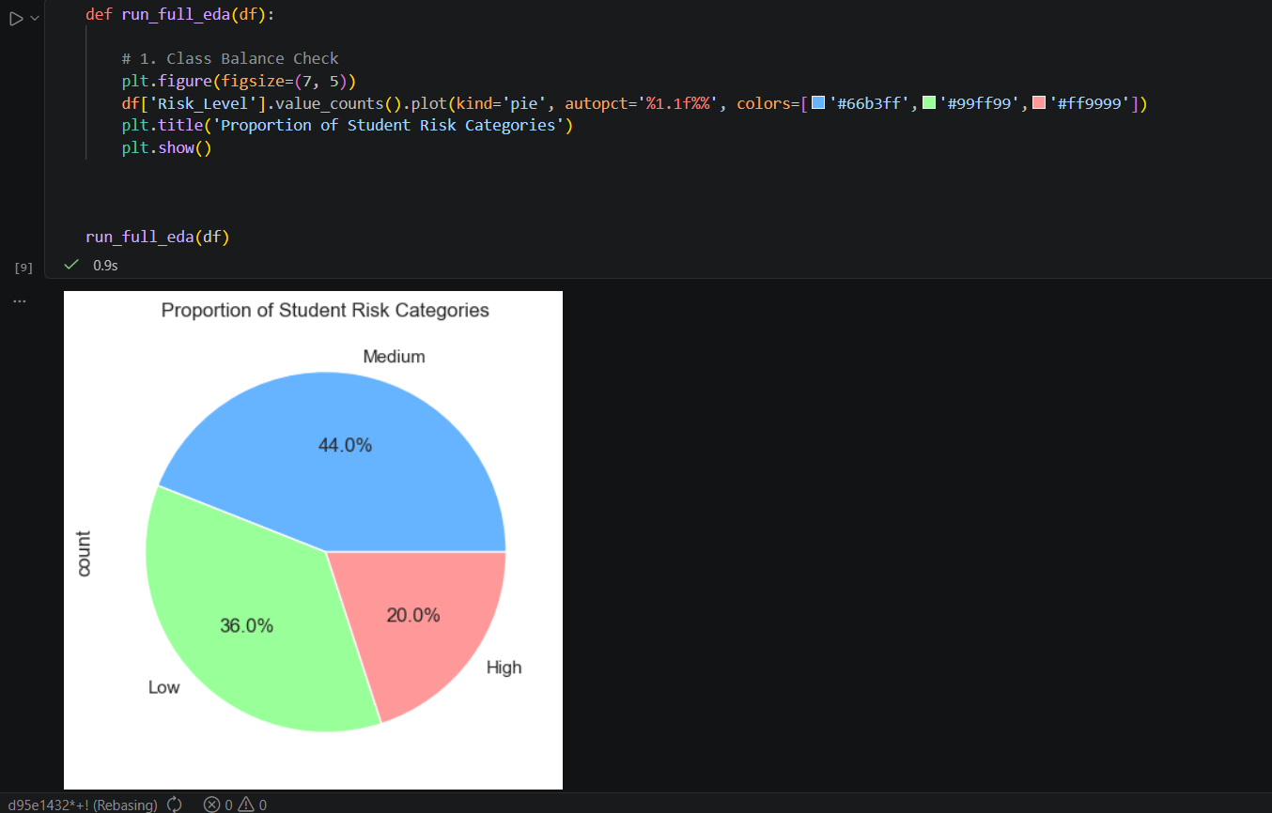

Snippet 8.1: Model Evaluation Results
